**NATIONAL COMMUNICATIONS AUTHORITY**

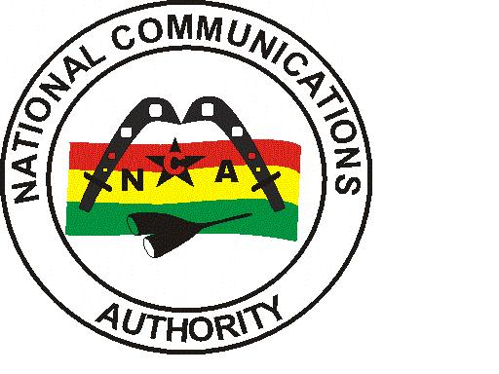

**VODAFONE 4G COVERAGE REPORT – GREATER ACCRA REGION**

|  |
| --- |
| Test conducted | March 2022 |

**Contents**

List of Figures 1

List of Tables 1

1.0 EXECUTIVE SUMMARY 2

1.1 METHODOLOGY 2

1.2 FINDINGS AND ANALYSIS 3

1.2.1 Test Locations 3

1.2.2 Coverage Status 5

1.2.3 4G Coverage Plot 6

1.2.4 RSRP Sampling Distribution 13

1.3 CONCLUSION 14

## List of Figures

Figure 1. 4G Coverage Plot – Amasaman 6

Figure 2. 4G Coverage Plot – Dansoman 7

Figure 3. 4G Coverage Plot – Dodowa 7

Figure 4. 4G Coverage Plot – Kpone 8

Figure 5. 4G Coverage Plot – LA 8

Figure 6. 4G Coverage Plot – Adenta 9

Figure 7. 4G Coverage Plot – Sowutuom 9

Figure 8. 4G Coverage Plot **–** Nungua 10

Figure 9. 4G Coverage Plot – Abokobi 10

Figure 10. 4G Coverage Plot – Madina 12

Figure 11. 4G Coverage Plot – Kokomlele 12

Figure 12. 4G Coverage Plot – Prampram 12

Figure 13. 4G Coverage Plot – Tema 12

Figure 14. 4G Coverage Plot **–** Sege 13

Figure 15. 4G Coverage Samples Plot 13

## List of Tables

Table 1: Signal Strength Range 2

Table 2: 4G Coverage Assessment Schedule and Test Locations 3

Table 3: Coverage Status and Average Signal strength for each test location 5

## 1.0 EXECUTIVE SUMMARY

In order to monitor and ensure compliance of coverage obligations of Broadband Wireless Access Service providers, a 4G Coverage verification campaign was carried out from 11th April to 9th March, 2022 in fourteen (14) District Capitals in the GREATER ACCRA Region. The findings of the audit exercise revealed VODAFONE’s 4G coverage presence in thirteen (13) out of fourteen (14) tested district capitals; with major coverage improvement required in all fourteen (14) district capitals.

## 1.1 METHODOLOGY

The methodology used in this exercise relied on field tests performed using NEMO INVEX II for data collection.

Measurement samples were collected in idle 4G-locked drive-test mode along pre-defined route within selected district capitals in the Greater Accra Region.

The coverage map shows the Reference Signal Received Power (RSRP) of the 4G network. In each plot is a legend to indicate definitions of signal strength attained by operators during measurement.

Coverage levels in green falls in the range of -90dBm and above and are considered good. Those between -90 and -105dBm are considered fair and are indicated in yellow. The red samples represent poor coverage in the range of -105 to -120dBm. The black samples represent areas with no coverage.

**Coverage Legend**

|  |  |  |  |
| --- | --- | --- | --- |
| **From (**≥**)** | **To (<)** | **Colour (RGB)** | **Grade** |
| ≥ | -120 |  | Non-Existent |
| -120 | -105 |  | Poor |
| -105 | -90 |  | Fair |
| -90 | ≤ |  | Good |

The main indicators used for this exercise was based on parameters below:

* Signal Strength (dBm)
* Coverage Status

Generally, the signal strength as seen in NEMO WIND CATCHER is shown below:

**Table 1: Signal Strength Range**

|  |  |  |  |  |
| --- | --- | --- | --- | --- |
| Radio Access Technology | Signal Strength Range (dBm) | | | |
| LTE FDD/TDD | -120>RSRP | –120≤ RSRP < -105 | –105≤ RSRP< –90 | –90 ≤RSRP < –20 |
| Rating | Non-existent | Poor | Fair | Good |

The essence of the idle 4G-locked mode of coverage sample collection was to obtain on the average a signal strength measurement which is representative of the coverage situation in each of the district capitals that was driven.

A “**Not Covered**” coverage status is rated on the basis that either a “No LTE signal” was detected by the measurement system or the average RSRP level obtained was less than **-120 dBm** as stipulated under Section 1.5 of Annex A of the 4G Licence.

A “**Not Maintained”** coverage status is rated on the basis that even though a “No LTE signal” was detected or RSRP level obtained was less than -120 dBm, an independent analysis by the Authority confirmed that coverage had existed but was not maintained at the period of the drive.

## 1.2 FINDINGS AND ANALYSIS

## 1.2.1 Test Locations

The 4G monitoring exercise was started in the Greater Accra Region on 11th March, 2022 at 10:22am and ended on 9th March, 2022 at 1:22pm.

The test was conducted on perceived busy hour periods depending on the social and business activities and subscriber behaviour in the Region. Test was carried out every day for four (4) days in each District Capital.

Table 2 below indicates detailed locations and times at which the tests were conducted.

**Table 2: 4G Coverage Assessment Schedule and Test Locations**

| CLUSTER | DATE | TIME | DRIVEN ROUTE |
| --- | --- | --- | --- |
| A | 11/03/2022 | 10:22 am - 01:22 pm | Adenta |
| B | 11/03/2022 | 05:36 pm - 07:37 pm | Abokobi |
| C | 12/03/2022 | 07:58 am - 11:05 am | Adenta |
| D | 12/03/2022 | 05:58 pm - 07:59 pm | Abokobi |
| E | 13/03/2022 | 07:55 am - 10:58 am | Adenta |
| F | 13/03/2022 | 02:38 pm - 04:38 pm | Abokobi |
| G | 14/03/2022 | 02:21 pm - 03:33 pm | La |
| H | 14/03/2022 | 12:00 pm - 03:03 pm | Adenta |
| I | 14/03/2022 | 03:22 pm - 05:28 pm | Abokobi |
| J | 15/03/2022 | 10:19 am - 12:39 pm | Nungua |
| K | 15/03/2022 | 10:30 am - 12:27 pm | Amasaman |
| L | 15/03/2022 | 04:02 pm - 05:35 pm | La |
| M | 16/03/2022 | 08:13 am - 09:39 am | La |
| N | 16/03/2022 | 09:08 am - 11:46 am | Amasaman |
| O | 16/03/2022 | 02:44 pm - 05:09 pm | Nungua |
| P | 17/03/2022 | 06:43 am - 08:22 am | La |
| Q | 17/03/2022 | 08:58 am - 11:21 am | Amasaman |
| R | 17/03/2022 | 04:07 pm - 05:56 pm | Nungua |
| S | 18/03/2022 | 09:16 am - 11:44 am | Amasaman |
| T | 18/03/2022 | 09:54 am - 12:35 pm | Nungua |
| U | 21/03/2022 | 10:26 am - 11:59 am | Tema |
| V | 22/03/2022 | 09:37 am - 12:13 pm | Dansoman |
| W | 22/03/2022 | 12:17 pm - 01:40 pm | Sege |
| X | 22/03/2022 | 04:03 pm - 05:29 pm | Tema |
| Y | 22/03/2022 | 04:08 pm - 06:59 pm | Sowutuom |
| Z | 23/03/2022 | 08:00 am - 11:01 am | Dansoman |
| AA | 23/03/2022 | 01:27 pm - 02:48 pm | Sege |
| AB | 23/03/2022 | 02:43 pm - 05:43 pm | Sowutuom |
| AC | 23/03/2022 | 05:17 pm - 06:31 pm | Tema |
| AD | 24/03/2022 | 07:07 am - 10:19 am | Dansoman |
| AE | 24/03/2022 | 10:00 am - 11:13 am | Sege |
| AF | 24/03/2022 | 11:30 am - 10:57 pm | Sowutuom |
| AG | 24/03/2022 | 02:42 pm - 04:04 pm | Tema |
| AH | 25/03/2022 | 08:07 am - 11:08 am | Dansoman |
| AI | 25/03/2022 | 02:25 pm - 03:30 pm | Sege |
| AJ | 25/03/2022 | 02:52 pm - 06:05 pm | Sowutuom |
| AK | 28/03/2022 | 09:22 am - 02:45 pm | Madina |
| AL | 28/03/2022 | 04:51 pm - 06:30 pm | Dodowa |
| AM | 29/03/2022 | 08:18 am - 01:38 pm | Madina |
| AN | 29/03/2022 | 02:23 pm - 03:45 pm | Dodowa |
| AO | 30/03/2022 | 09:12 am - 02:50 pm | Madina |
| AP | 30/03/2022 | 01:04 pm - 02:56 pm | Kpone |
| AQ | 30/03/2022 | 05:07 pm - 06:32 pm | Dodowa |
| AR | 31/03/2022 | 09:27 am - 02:57 pm | Madina |
| AS | 31/03/2022 | 01:38 pm - 03:18 pm | Kpone |
| AT | 31/03/2022 | 05:57 pm - 07:16 pm | Dodowa |
| AU | 01/04/2022 | 08:51 am - 10:41 am | Prampram |
| AV | 01/04/2022 | 03:05 pm - 04:42 pm | Kpone |
| AW | 02/04/2022 | 08:15 am - 10:02 am | Prampram |
| AX | 02/04/2022 | 11:59 am - 01:53 pm | Kpone |
| AY | 03/04/2022 | 06:29 am - 08:07 am | Prampram |
| AZ | 04/04/2022 | 08:10 am - 10:07 am | Prampram |
| BA | 06/04/2022 | 09:21 am - 11:31 am | Kokomlemle |
| BB | 07/04/2022 | 09:14 am - 11:23 am | Kokomlemle |
| BC | 08/04/2022 | 09:03 am - 11:23 am | Kokomlemle |
| BD | 09/04/2022 | 08:48 am - 11:20 am | Kokomlemle |

## 1.2.2 Coverage Status

**Table 3: Coverage Status and Average Signal strength for each test location**

| **District Capital** | **Average RSRP**  **(≥ -120dBm)** | | | | **Coverage Status** |
| --- | --- | --- | --- | --- | --- |
| **Day 1** | **Day 2** | **Day 3** | **Day 4** |
| Abokobi | -92.49 | No Data | No Data | -90.41 | Fair 4G Coverage in Abokobi. Major coverage improvement is required around the Hillview Guest Center, Abokobi Station and Bloom Mart Abokobi Teiman. |
| Adenta | -88.21 | -87.52 | No Data | -85.33 | Good 4G Coverage in Adenta. Major coverage improvement is needed around SSNIT Flat Adenta Municipal Assembly and Shield International School. |
| Amasaman | -94.48 | -95.37 | -95.31 | -94.05 | Fair 4G Coverage in Amasaman. Major improvements needed around Stadium Junction, Amasaman post office, Amasaman Area market and Amasaman hospital. |
| Dansoman | -89.72 | -88.53 | -88.79 | -89.33 | Good network coverage in Dansoman. Major network coverage improvement is required in and around the Dansoman market and Christ Ambassadors School. |
| Dodowa | -95.07 | -97.23 | -96.26 | -96.04 | Fair 4G Coverage. Major coverage improvement needed in the whole community. |
| Kokomlemle | -89.63 | -89.81 | -88.24 | -93.37 | Good 4G Coverage in Kokomlele. Major coverage improvement is requiredin and around Hubtel, Ayawaso Central Municipal Assembly, Bonsu road, Bestpoint savings and loan and Mallam Atta market. |
| Kpone | -92.73 | -93.85 | No Data | -96.35 | Fair 4G Coverage. Major Coverage improvement required throughout Kpone. |
| La | -86.15 | -86.59 | -86.46 | -87.67 | Good 4G Coverage. However, major coverage improvement is required around the Labone senior high school, Labadi market, Latenu radio and Star oil company limited – HQ. |
| Madina | -83.44 | -83.01 | -82.63 | -88.28 | Good 4G Coverage in Madina. Major coverage improvement is required around the Presec Basic school, Ogbojo new market, M & K Xpress Auto Services and Madina Astro Turf. |
| Nungua | -82.42 | -84.66 | -84.76 | -82.45 | Good 4G Coverage. Major coverage improvement is required around Ravico estates Nungua especially around the Beach Drive and the GCB Training School. |
| Prampram | -97.78 | No Data | No Data | No Data | Fair 4G Coverage. Major coverage improvement needed around the Abia D/A Basic school, Prampram cemetery, Ghana water company limited and the Prampram Church of Christ. |
| Sege | **-120.03** | No Data | No Data | No Data | Non-existent 4G Coverage. Major coverage improvement is needed around the Semanhyia fuel station and In Him chemical. |
| Sowutuom | -82.42 | -79.89 | -81.17 | -83.30 | Good 4G Coverage in Sowutuom. However, major coverage improvement is needed around the Puma Filling Station and Deseret Hospital. |
| Tema | -87.71 | -83.55 | -80.27 | -83.29 | Good 4G Coverage, however, major coverage improvement is required around the Brewnia street, the Chops Garden Grill, Healthwise Medical Centre and DSTV office. |

## 

## 1.2.3 4G Coverage Plot

Figure 1. 4G Coverage Plot – Amasaman

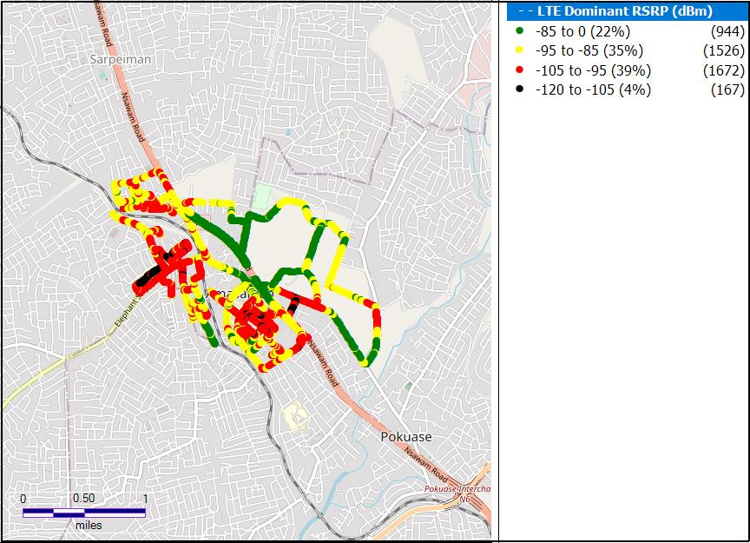**Remarks:** Fair 4G Coverage in Amasaman. Major improvements needed around Stadium Junction, Amasaman post office, Amasaman Area market and Amasaman hospital.

Figure 2. 4G Coverage Plot – Dansoman

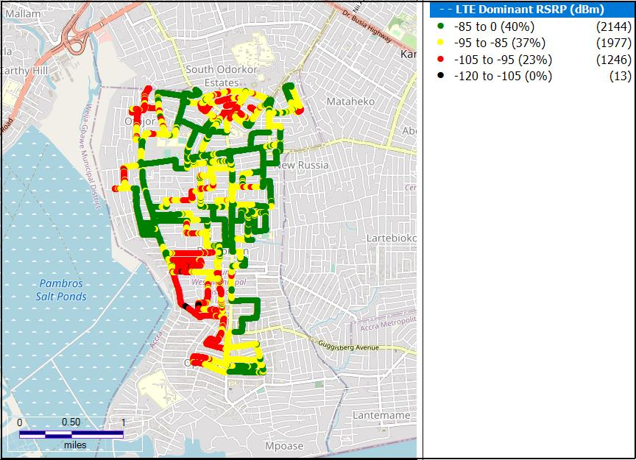

**Remarks:** Good network coverage in Dansoman. Major network coverage improvement is required in and around the Dansoman market and Christ Ambassadors School.

Figure 3. 4G Coverage Plot – Dodowa

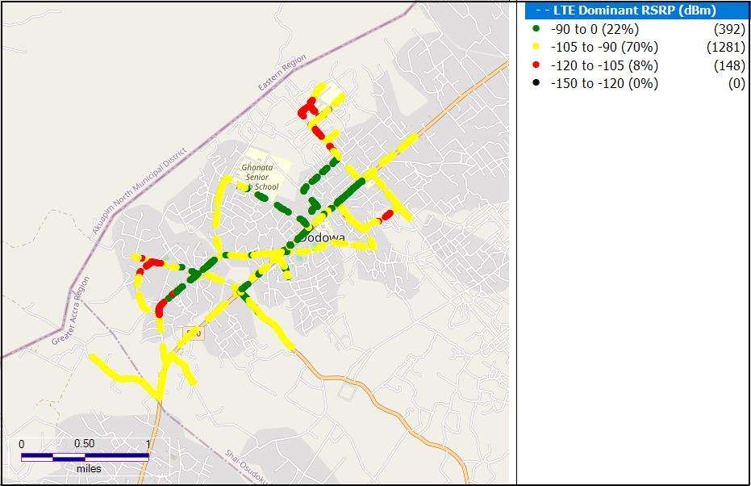

**Remarks:** Fair 4G Coverage. Major coverage improvement needed in the whole community.

Figure 4. 4G Coverage Plot – Kpone

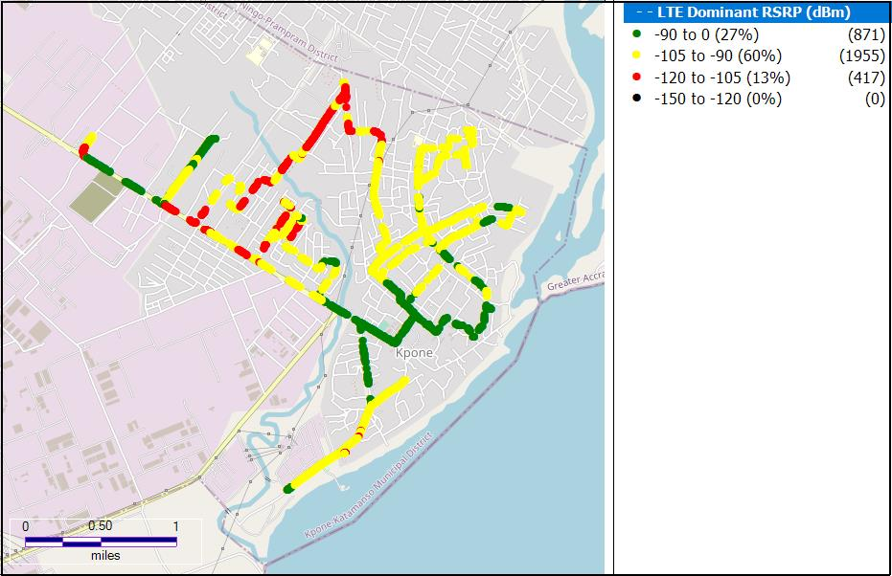

**Remarks:** Fair 4G Coverage. Major Coverage improvement required throughout Kpone.

Figure 5. 4G Coverage Plot – LA

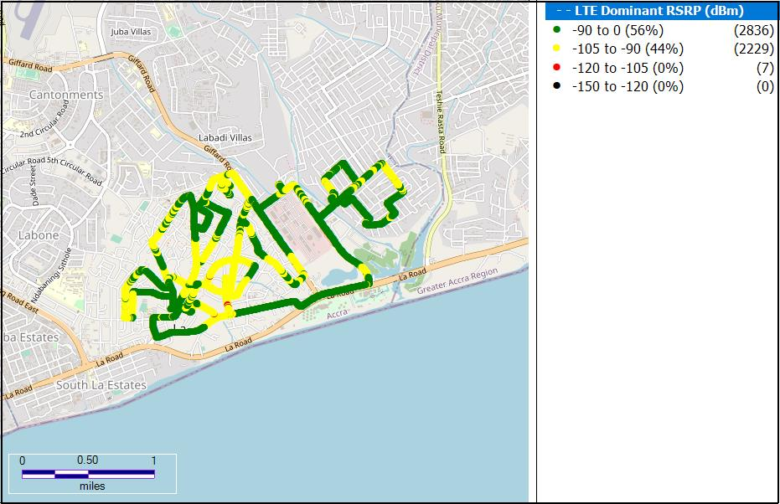

**Remarks:** Good 4G Coverage. However, major coverage improvement is required around the Labone senior high school, Labadi market, Latenu radio and Star oil company limited – HQ

Figure 6. 4G Coverage Plot – Adenta

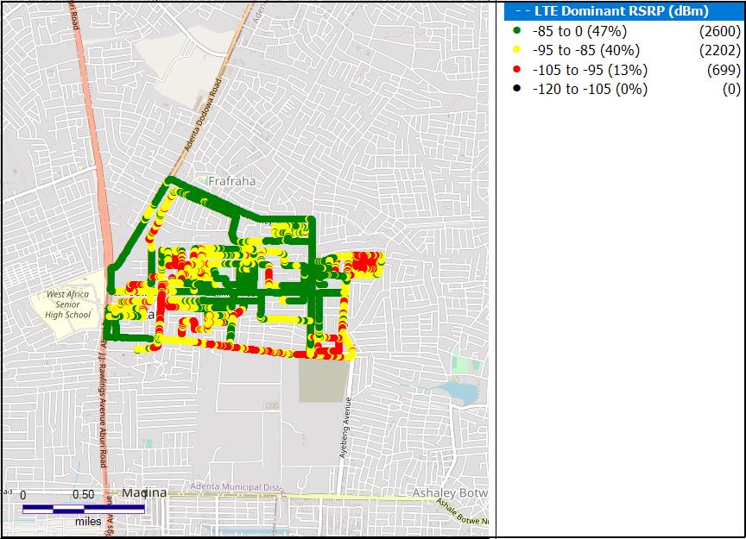

**Remarks:** Good 4G Coverage in Adenta. Major coverage improvement is needed around SSNIT Flat , Adenta Municipal Assembly and Shield International School.

Figure 7. 4G Coverage Plot – Sowutuom

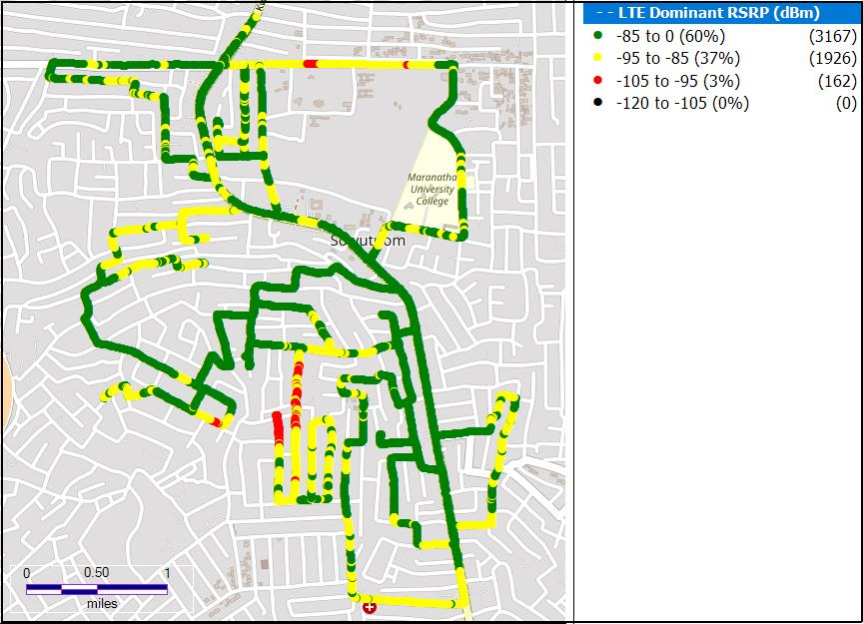

**Remarks:** Good 4G Coverage in Sowutuom. However, major coverage improvement is needed around the Puma Filling Station and Deseret Hospital.

**Figure 8. 4G Coverage Plot – Nungua**

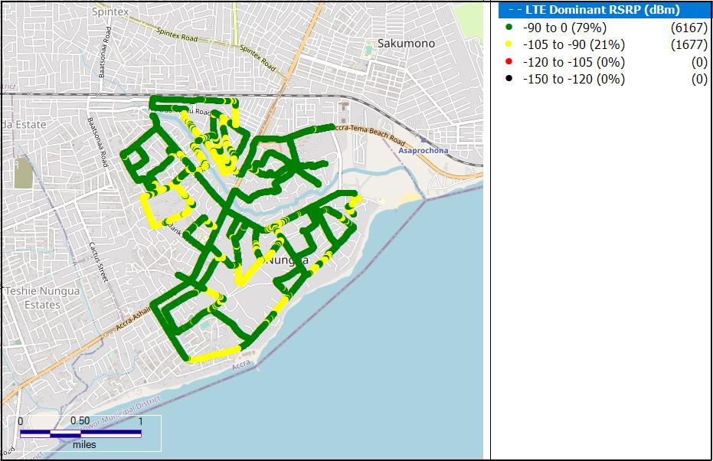

**Remarks:** Fair 4G Coverage. Major coverage improvement is required around Ravico estates Nungua especially around the Beach Drive and the GCB Training School.

Figure 9. 4G Coverage Plot – Abokobi

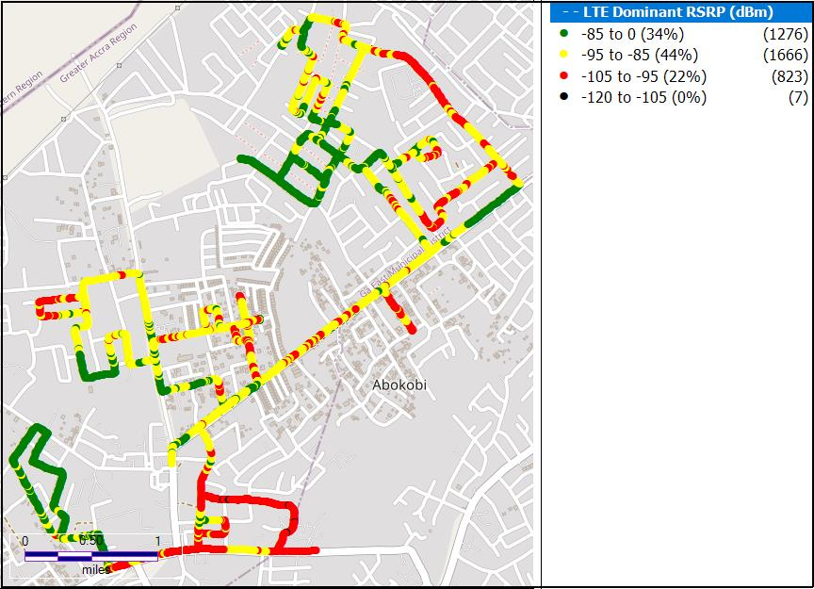

**Remarks:** Fair 4G Coverage. Major coverage improvement is required around the Hillview Guest Center , Abokobi Station and Bloom Mart Abokobi Teiman.

Figure 10. 4G Coverage Plot – Madina

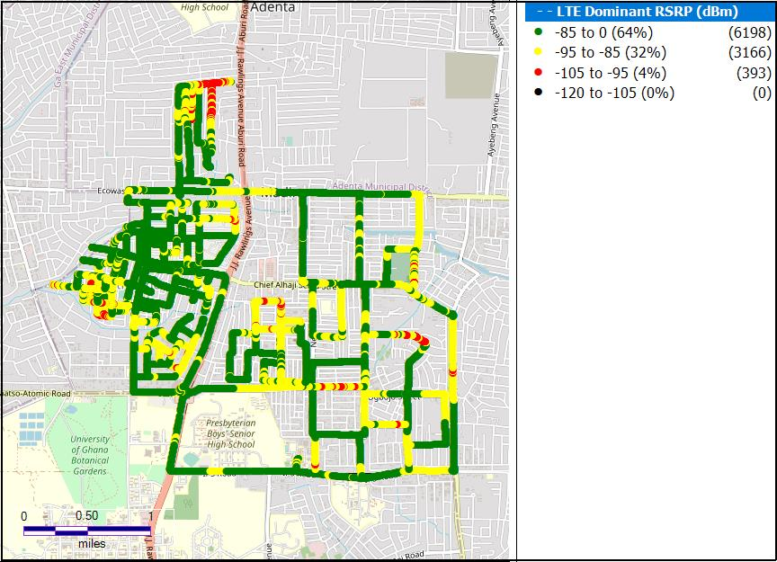

**Remarks:** Good 4G Coverage in Madina. Major coverage improvement is required around the Presec Basic school, Ogbojo new market ,M & K Xpress Auto Services and Madina Astro Turf.

Figure 11. 4G Coverage Plot – Kokomlele

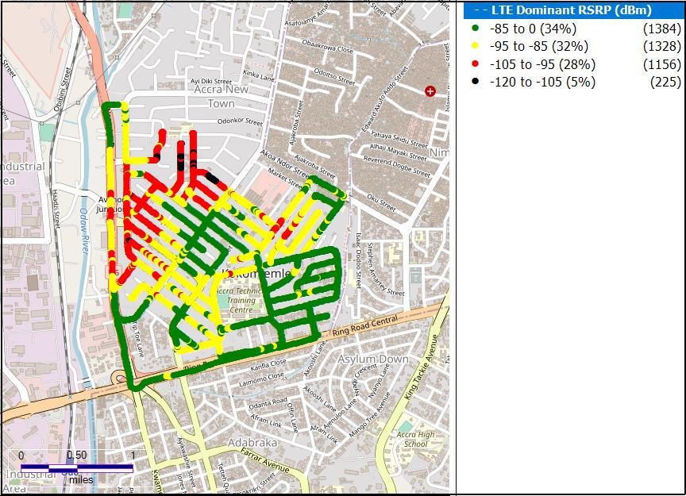

**Remarks:** Good 4G Coverage in Kokomlele . Major coverage improvement is requiredin and around Hubtel, Ayawaso Central Municipal Assembly, Bonsu road, Bestpoint savings and loan and Mallam Atta market.

Figure 12. 4G Coverage Plot – Prampram

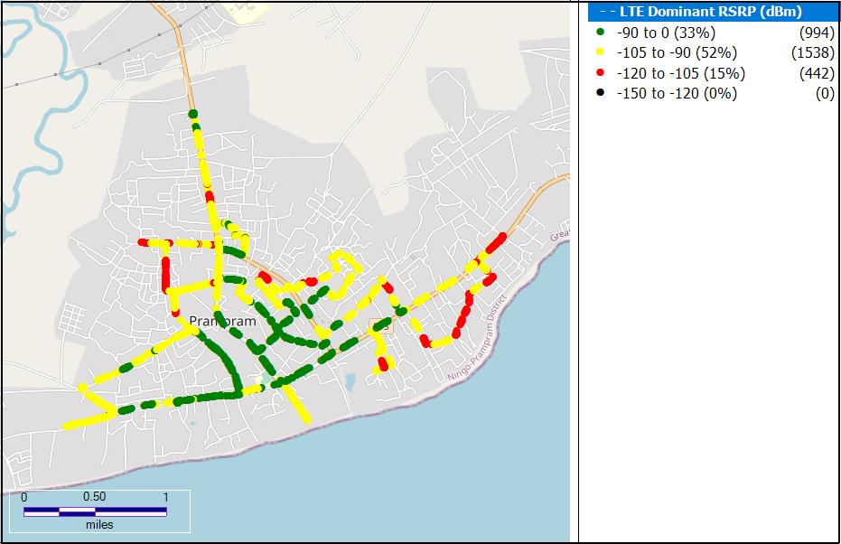

**Remarks:** Fair 4G Coverage. Major coverage improvement needed around the Abia D/A Basic school, Prampram cemetery, Ghana water company limited and the Prampram Church of Christ.

Figure 13. 4G Coverage Plot – Tema

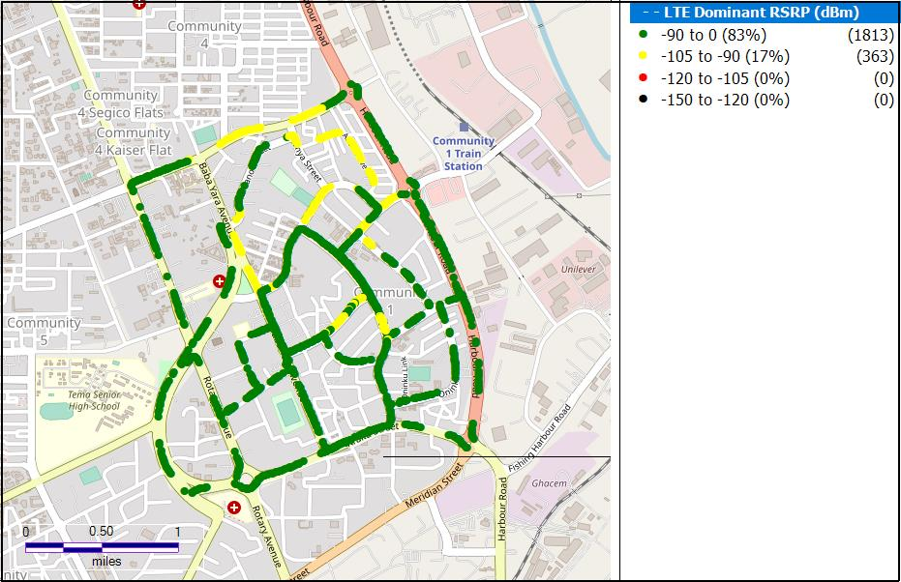

**Remarks:** Good 4G Coverage, however, major coverage improvement is required around the Brewnia street, the Chops Garden Grill, Healthwise Medical Centre and DSTV office.

**Figure 14. 4G Coverage Plot – Sege**

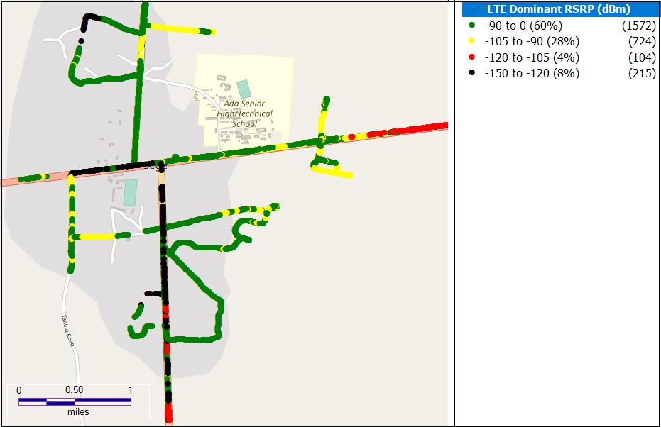

**Remarks:** Non-existent 4G Coverage. Major coverage improvement is needed around the Semanhyia fuel station and In Him chemical.

## 1.2.4 RSRP Sampling Distribution

Figure 13. 4G Coverage Samples Plot

**Remarks**: VODAFONE recorded highest count of RSRP samples in the range –90 ≤RSRP < –20 dBm. Major improvement is required in the 59.94% of samples that are out of good coverage range.

## CONCLUSION

* VODAFONE has 4G coverage presence in thirteen (13) out of fourteen (14) District Capitals tested in the Greater Accra Region.
* VODAFONE requires major improvement in its 4G coverage in all fourteen (14) district capitals tested.